Safety Data Sheet Dynaflux SDS 200A 07/18/2018
Product: 200 Heavy Duty Anti-Spatter (Aerosol)

Part 1: Product and Company Identification
Identification 200A
Trade Name: 200 Heavy Duty Anti-Spatter (Aerosol)
Product Use: Heavy Duty Ant-Spatter.
Manufacturers Name: Dynaflux, Inc.
241 Brown Farm Rd.
Cartersville, GA 30120 U.S.A.
Emergency Telephone Number: For U.S.: 800-255-3924 International: 813-248-0585

Part 2: Hazard(s) Identification
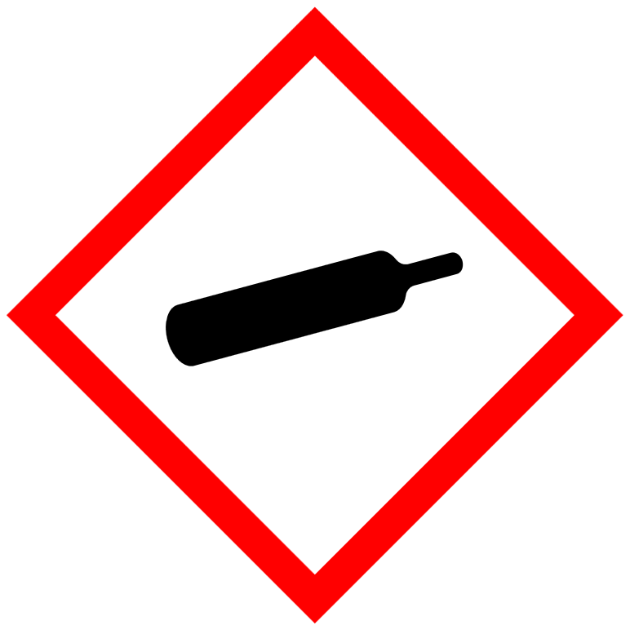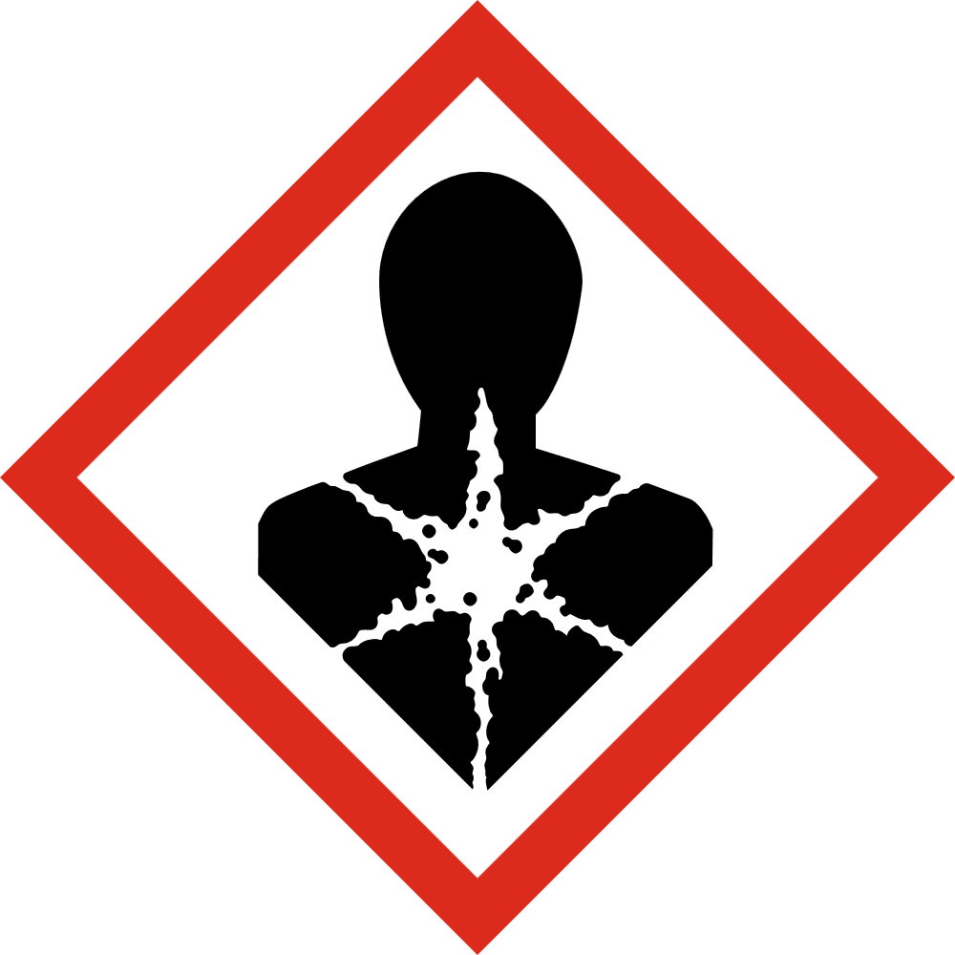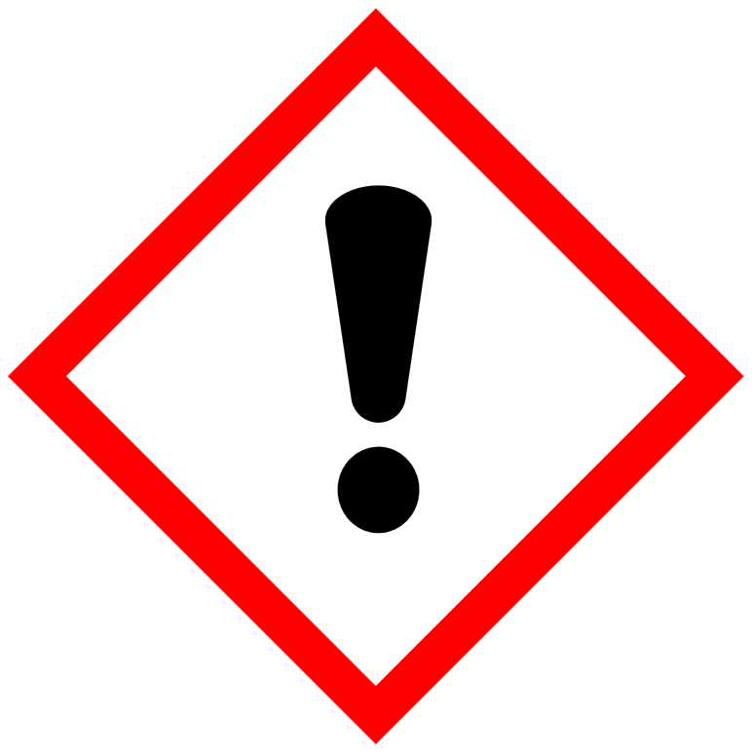
Signal Word: DANGER
H229: Pressurized container: may burst if heated
H351: Suspected of causing cancer

Warning:
Contains gas under pressure. May explode if heated.
May cause allergy or asthma symptoms or breathing difficulties if inhaled.
May cause damage to organs.
May be harmful if swallowed.

Part 3: Composition / Information on ingredients

 |  | SARA III | PEL |  | TLV | Carcinogen
Hazardous Ingredients | CAS No. | List | PPM |  | PPM | Refer. Source
Dichloromethane | 75-09-2 | Yes | 25 |  | 12.5 | IARC NTP
Potential Acute Health Effects: Very hazardous in case of eye contact (irritant), of ingestion, of inhalation. Hazardous in case of skin contact (irritant, permeator). Inflammation of the eye is characterized by redness, watering and itching.

Part 4: First Aid Measures
Eye Contact: Flush with water for 15 minutes. If irritation persists call a physician. GHS: Category 2A
Skin Contact: Flush with water. Wash with soap and water. Apply a lotion. GHS: Category 2
Inhalation: Move to fresh air.
Ingestion: Do not induce vomiting. Give several large glasses of water. Seek medical attention. GHS: Category 4
Reproductive Toxicity: GHS Category 2
Carcinogenicity: GHS Category 2

Part 5: Fire Fighting Measures
Flashpoint: Nonflammable Flame Projection Test
U.E.L.: None Established
L.E.L. : None Established
Auto Ignition Temperature: 662°C.
Combustion Products: Carbon dioxide, carbon monoxide, hydrogen chloride and small amounts of phosgene.
Extinguishing Media: Foam, CO2, Dry chemical
Unusual Fire and Explosion Hazard: use a self contained breathing apparatus. Use water fog to cool containers to prevent rupturing.

Part 6: Accidental Release Measures
Small Spill: Soak up with absorbent material, i.e. kitty litter, clay or dirt. Sweep up and place in a labeled closed container.
Large Spill: Keep unauthorized people from the area. Use self contained breathing apparatus. Dike area and pump contents to a labeled, closed container. Absorb residue and sweep up. Place in a closed, labeled container.

Part 7: Handling and Storage
Leave in the shipping containers. Store in a cool dry place. Do not expose aerosols to temperatures above 120° F or the container may rupture.

Part 8: Exposure Control / Personal Protection
If vapor exceeds TLV use a approved respirator. Use mechanical ventilation in confined spaces. Wear safety glasses and protective gloves.

Part 9: Physical and Chemical Properties
Boiling Point: 39.8°C
Vapor Pressure : 47.33 KPa
Vapor Density: 2.93
Octanol / Water Partition Coefficient.: 1.25
Appearance and Odor: Clear to amber liquid with solvent odor.
Specific Gravity: 1.37
Evaporation Rate (BuAc=1): NA
Water Reactive: No
VOC: 3% by weight

Part 10: Stability and Reactivity
Stability- Product is stable
Hazardous Polymerization- will not occur.
Conditions to Avoid- Ignition sources, open flames, amines and strong bases.

Part 11: Toxicological Information
Ingestion: Rat LD50 1500-2500mg/kg
Inhalation: Rat LC50 10,000 ppm
Carcinogenicity Classification: N.T.P. Anticipated Carcinogen. IARC: Possible carcinogen; 2B
Reproductive Toxicity: animal studies- None
Genetic Toxicity-negative results from animal studies.

Part 12: Ecological Information
Potential for mobility in soil is high.
Octanol/Water partition coefficient: 1.25
Organic carbon/water partition coefficient: 24
Atomospheric half life: 79-110 days
Biodegradation 5-26% 28 days
LC50 bluegil:l 224 mg/l
Aquatic Toxicity EC50 water flea. Immobilization: 480 mg/l

Part 13: Disposal Consideration
Do not dump into any sewers, on the ground or into any body of water. Send to a permitted recycler.

Part 14: Transportation Information
D.O.T.
Consumer Commodity O.R.M.-D., 48580 Sub 3
IMDG- (Vessel)
Proper Shipping Name: Aerosols, (Dichloromethane), Limited Quantity
Hazard Class: Class 2.2, 6.1
Packing Group: III
UN Number: UN1950
Marine Pollutant – No

Part 15: Regulatory Information
Section 311 and 312
Immediate Health Hazard – Yes
Delayed Heath Hazard- Yes
Fire Hazard – No
Reactive Hazard – No
Section 313- Dichloromethane
TSCA – The product on this MSDS, or all of its components, is listed under TSCA.
CEPA-(DSL) Listed

California Proposition 65 Statement:

WARNING: This product can expose you to Dichloromethane, a chemical known to the State of California to cause cancer.
For more information, go to www.p65Warnings.ca.gov/product.

Part 16: Other Information
Dynaflux, Inc.
241 Brown Farm Rd.
Cartersville, GA 30120 U.S.A.

Disclaimer of Expressed and implied Warranties:
The information presented in this Safety Data Sheet is based on data believed to be accurate as of the date of the l Safety Data sheet was prepared. No responsibility is assumed for any damage or injury resulting from abnormal use or from any failure to adhere to recommended practices as specified on the label copy.

