Safety Data Sheet Dynaflux SDS 200B 07/18/2018
Product: 200 Heavy Duty Anti-Spatter (Liquid)

Part 1: Product and Company Identification
Identification 200B
Trade Name: 200 Heavy Duty Anti-Spatter
Product Use: Heavy Duty Ant-Spatter.
Manufacturers Name: Dynaflux, Inc.
241 Brown Farm Rd.
Cartersville, GA 30120 U.S.A.
Preparation Date: 08/13/2013
Emergency Telephone Number: For U.S.: 800-255-3924 International: 813-248-0585

Part 2: Hazard(s) Identification
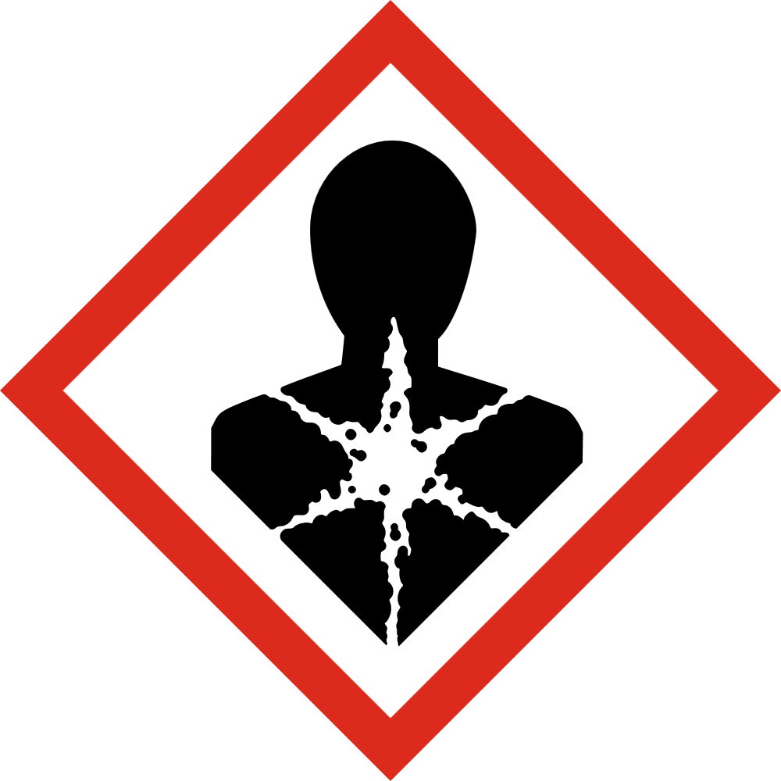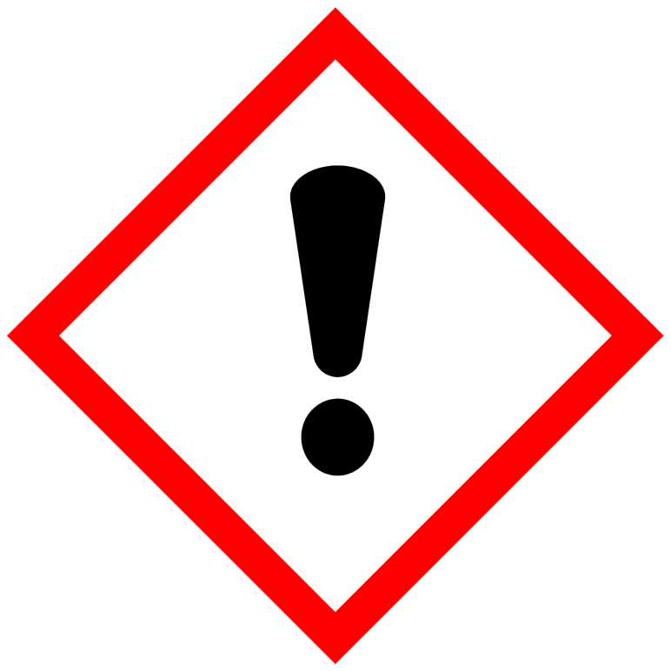
Signal Word:
Danger
Hazard Statements
Causes skin irritation
Causes serious eye irritation
May cause drowsiness or dizziness
May cause cancer

Part 3: Composition / Information on ingredients

 |  |  |  | SARA III | PEL |  | TLV | Carcinogen
Hazardous Ingredients |  | CAS No. |  | List | PPM |  | PPM | Refer. Source
Dichloromethane |  | 75-09-2 |  | Yes | 25 |  | 12.5 | IARC NTP
Potential Acute Health Effects: Very hazardous in case of eye contact (irritant), of ingestion, of inhalation. Hazardous in case of skin contact (irritant, permeator). Inflammation of the eye is characterized by redness, watering and itching.

Part 4: First Aid Measures
Eye Contact:
Check for and remove any contact lenses. In case of contact, immediately flush eyes with plenty of water for at least 15 minutes. Cold water may be used. Get medical attention immediately. GHS Subcategory 2A
Skin Contact:
In case of contact, immediately flush skin with plenty of water. Cover the irritated skin with an emollient. Remove contaminated clothing and shoes. Cold water may be used. Wash clothing before reuse. Thoroughly clean shoes before reuse. Get medical attention. GHS Category 3
Inhalation:
If inhaled, remove to fresh air. If not breathing, give artificial respiration. If breathing is difficult, give oxygen, Get medical attention.

Ingestion:
Do NOT induce vomiting unless directed to do so by medical personnel. Never give anything by mouth to an unconscious person. If large quantities of this material are swallowed call a physician immediately. Loosen tight clothing such as a collar, tie, belt or waistband. GHS Category 4
Reproductive Toxicity: GHS Category 2
Carcinogenicity: GHS Category 2

Part 5: Fire Fighting Measures
Auto-Ignition Temperature: 556°C (1032.8°F).
Flash Points: Non-flammable.
Flammable Limits: LOWER: 12% UPPER 19%
Products of Combustion: These products are carbon oxides (CO, CO2), halogenated compounds and small amounts of phosgene.
Fire Hazards in Presence of Various Substances: Not available.
Fire Fighting Media and Instructions: SMALL FIRE: Use DRY chemical powder. LARGE FIRE: Use water spray, fog or foam. Do not use water jet. Cool containers to help prevent rupturing.

Part 6: Accidental Release Measures
Small Spill:
Mop up or absorb with an inert dry material and place in an appropriate waste disposal container.
Large Spill:
Dike area and pump to an intact, labeled container. Mop up or absorb on an inert material. Sweep up and place in a labeled container.

Part 7: Handling and Storage
Keep away from heat. Do not ingest. Do not breathe gas/fumes/vapor/spray. In case of insufficient ventilation, wear suitable respiratory equipment. Avoid contact with skin and eyes.
Storage: Keep container tightly closed. Keep container in a cool, well-ventilated area.

Part 8: Exposure Control / Personal Protection
Engineering Controls:
Provide exhaust ventilation or other engineering controls to keep the airborne concentrations of vapors below their respective threshold limit value. Ensure that eyewash stations and safety showers are proximal to the work station location.
Personal Protection:
Splash goggles. Apron. Vapor respirator. Be sure to use an approved/certified respirator. Gloves
Personal Protection in Case of a Large Spill:
Splash goggles, full suit. Vapor respirator. Boots. Gloves. A self- contained breathing apparatus should be used to avoid inhalation of the product.
Exposure Limits:
TWA: 50 from ACGIH (TLV) [United States] TWA: 174 from ACGIH (TLV) [United States] Consult local authorities for acceptable exposure limits.

Continued

Part 9: Physical and Chemical Properties
Physical state and appearance: Light amber liquid.
Odor: Mild, sweet
Molecular Weight: 84.94
Specific Gravity: (water =1.0): 1.33
Solubility in Water (weight %): 1.32 gm/100gm @ 77°F (25°C)
pH: Not applicable
Boiling Point: 104°F (40°C).
Vapor Pressure: 350mm Hg at 68°F (20°C).
Vapor Density (Air=1): 2.9
Evaporation Rate: 0.7 Compared to: Ethyl Ether = 1
% Volatiles: 100
Flash Point: None

Part 10: Stability and Reactivity
Stability:
Stable under recommended storage conditions.
Avoid: Incompatible products
Incompatibilities:
Open flames, amines and strong bases.
Hazardous Polymerization:
Hazardous polymerization does not occur.

Part 11: Toxicological Information
Component Analysis – LD50/LC50

Dichloromethane (75-09-2)
Ingestion: Rat: LD50 1500-2500 mg/kg
Inhalation: Rat LC50 10,000 ppm

Carcinogenicity Classification: N.T.P. Anticipated Carcinogen. IARC: Possible carcinogen; 2B
Reproductive Toxicity: animal studies-None

Part 12: Ecological Information
Potential for mobility in soil is high.
Octanol/Water partition coefficient: 1.25
Organic carbon/water partition coefficient: 24
Atomospheric half life: 79-110 days
Biodegradation 5-26% 28 days
LC50 bluegil:l 224 mg/l
Aquatic Toxicity EC50 water flea. Immobilization: 480 mg/l

Part 13: Disposal Consideration
Waste Information: Dispose of as special waste in compliance with local and national regulations. Waste codes should be assigned by the user based on the application for which the product was used. Incineration of waste material in an EPA-approved facility is recommended, allowing a solid, inert residue to form.
Other Disposal Considerations: Observe all Federal, State and Local Environmental regulations.

Part 14: Transportation Information
DOT Hazard Classification: Dichloromethane Solution, UN1953, 6.1, PG III,
RQ 1000lb / 454kg

Part 15: Regulatory Information
TSCA – The product on this MSDS, or all of its components, is listed under TSCA.
Section 311 Hazard Class: 6.1.
SARA 313 Toxic Chemicals:
The following ingredients are SARA 313 “Toxic Chemicals”.
Ingredient Name:
Dichloromethane (75-09-2)
WHMIS Classification (Canada):
CLASS D-1B: Material causing immediate and serous toxic effects (TOXIC). CLASS D-2A: Material causing other toxic effects.

DSCL (EEC): R22-harmful if swallowed. R38- irritating to skin. R41- Risk of serious damage to eyes. R45- may cause cancer.

California Proposition 65 Statement:

WARNING: This product can expose you to Dichloromethane, a chemical known to the State of California to cause cancer.
For more information, go to www.p65Warnings.ca.gov/product.

Part 16: Other Information

Dynaflux, Inc.
241 Brown Farm Rd.
Cartersville, GA 30120 U.S.A.

Disclaimer of Expressed and implied Warranties:
The information presented in this Safety Data Sheet is based on data believed to be accurate as of the date of the l Safety Data sheet was prepared. No responsibility is assumed for any damage or injury resulting from abnormal use or from any failure to adhere to recommended practices as specified on the label copy.

