Safety Data Sheet Dynaflux 395A 07/18/2018
Product: 395 Heavy Duty Anti-Spatter (Aerosol)

Part 1: Product and Company Identification
Identification 395A
Trade Name: 395 Heavy Duty Anti-Spatter
Product Use: Non-Solvent Anti-Spatter.
Manufacturers Name: Dynaflux, Inc.
241 Brown Farm Rd.
Cartersville, GA 30120 U.S.A.
Preparation Date: March 28, 2013
Emergency Telephone Number: CHEMTEL: For U.S.: 800-255-3924 International: 813-248-0585

Part 2: Hazard Identification
Contains No Hazardous Ingredients at or above 1%.
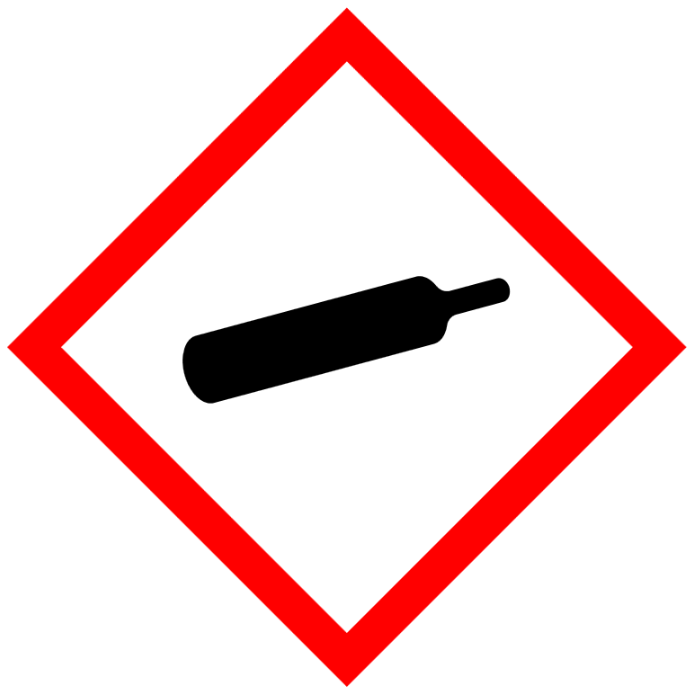
Signal Word: WARNING
H229: Pressurized container: may burst if heated

Emergency Overview:
This material is considered non-hazardous by the OSHA Hazard Communication Standard.
Caution: Contents Under Pressure.
Aerosol: Do not puncture or incinerate. Do not expose to heat or store at temperatures above 120°F.
Primary route(s) of entry. Skin and eye contact. Inhalation.
Eyes: May cause temporary irritation.
Skin: Prolonged skin contact may cause drying and defatting of skin.
Inhalation: My irritate muscosal tissue.
Ingestion: Not a like route of exposure (aerosol). Ingestion may result in nausea, abdominal discomfort or diarrhea.
Potential Chronic Health Effects: None
Carcinogenic Effects:
NTP: No
IARC: No
OSHA: No
ACGIH: No
Mutagenic Effects: None
Teratogenic Effects: None
Target Organs: None
Medical Conditions Aggravated by Exposure: None
Signs and Conditions: Stinging in eyes. Repeated or prolonged skin contact can cause redness, irritation and scaling if the skin (dermatitis).

Part 3: Composition / information on ingredients
Contains No Hazardous Ingredients at or above 1%.
Continued

H.M.I.S. |  |  |  |  | N.F.P.A.
Health | 1 |  |  |  | Health |  | 1
Flammability | 0 |  |  |  | Flammability |  | 0
Reactivity | 0 |  |  |  | Reactivity |  | 0
Special | B |  |  |  | Personal Protection |  | -
Part 4: First Aid Measures

Eyes: Flush eyes with cool, clean water (low pressure) for at least 15 minutes. Hold eyelids apart to ensure complete irrigation of
the eye and eyelid. If irritation persists seek medical attention. GHS: Subcategory 2B

Skin: Should irritation occur wash affected area with soap and water for 15 minutes. Lauder clothing before reuse. If irritation
persists seek medical attention.

Inhalation: No irritation with inhalation should occur. Remove to fresh air. If not breathing give artificial respiration. Seek
medical attention.

Ingestion: Ingestion is unlikely. Should ingestion occur, do not induce vomiting unless directed to do so by medical personnel.
Drink a glass of water or milk to dilute. Never give anything by mouth to an unconscious person. Seek medical attention
immediately.

Part 5: Fire Fighting Measures
Flashpoint: Nonflammable Flame Projection Test
U.E.L.: None Established
L.E.L. : None Established
Auto Ignition Temperature: NA
Combustion Products: Carbon dioxide, carbon monoxide, oxides of carbon.
Extinguishing Media: Class B extinguishers.
Unusual Fire and Explosion Hazard: Use a self- contained NIOSH-approved breathing apparatus. Use water fog to cool containers to prevent rupturing of containers. Aerosols may explode upon heating, spread fire and overcome sprinkler systems.

Part 6: Accidental Release Measures
Small Spill: Soak up with absorbent material, i.e. kitty litter, clay or dirt. Sweep up and place in a labeled closed container.
Large Spill: Keep unauthorized people from the area. Dike area and pump contents to a labeled, closed container. Absorb residue and sweep up. Place in a closed, labeled container. Dispose of properly.

Part 7: Handling and Storage
Leave in the shipping containers. Store in a cool dry place. Do not expose aerosols to temperatures above 120° F or the container may rupture. Store aerosol as Level 1 Aerosol (NFPA 30B).

Part 8: Exposure Control / Personal Protection
Personal Protection:
Eye: Safety Glasses with side shields conforming to appropriate regulations.
Hand Protection: None required. Use of chemically resistant gloves is recommended.
Respiratory Protection: Use of this product as per label instructions does not require the use of respiratory protection. If airborne concentrations are above the applicable exposure limits use NIOSH approved respiratory protection (organic vapor cartridge).

Part 9: Physical and Chemical Properties
Initial Boiling Point: 212°F (100 C)
Vapor Pressure : (PSIG @ 70°F): 90 psig
Vapor Density (Air=1): .81
Appearance and Odor: White thin odorless emulsion
Specific Gravity: (H2O)=1): .98 mmHg
Evaporation Rate (H2O=1): 1
Water Reactive: No
Solubility in water: Emulsifiable
Flash Point: None
Decomposition Temperature: Not Established
Auto Ignition Temperature: Not Established
Flammable Limits:
Lower: Not Established
Upper: Not Established
VOC Content: 3.18% (by weight)

Part 10: Stability and Reactivity
Stability- Product is stable
Hazardous Polymerization- will not occur.
Avoid extreme heat and freezing.

Part 11: Toxicological Information
An acute toxicity study of this product has not been conducted. Information given in this section relates only to individual constituents contained in this compound.

Part 12: Ecological Information
Ecotoxicity: No information available.
Persistence / Degradability: Not evaluated.
Bioaccumulation / Accumulation: No information available.
Mobility in Environment: No information available.

Part 13: Disposal Consideration
Waste must be disposed of in accordance with national, regional, provincial, state and local environmental control regulations.
Do not dump into any sewers, on the ground or into any body of water.

Part 14: Transportation Information
DOT HM-181 Shipping Information
D.O.T. Shipping Name – Consumer Commodity
Hazard Class or Division: ORM-D (on shipping carton)
UN Number: UN1950
Packing Group: None
Label(s) Required: ORM-D (on shipping carton)
Continued
IMDG-IMO:
UN No. : 1950
Class: 2
Shipping Name: Aerosols
Subsidiary Risk: 2.2
Labeling: Non-Flammable Gas
Packing Group: NA
Marine Pollutant: NO

Part 15: Regulatory Information
CERCLA: None
TSCA: All components of this product are TSCA Inventory Listed and/or are exempt.
SARA TITLE III SARA Section 311 and 312 (40 CFR 370) Hazard Categories: Sudden Release of Pressure.

State Regulations:
California Proposition 65
This product is not known to contain any of the components for which the State of California has found to cause cancer, birth defects or other reproductive harm.

All of the components of this product are included on the Canadian Domestic Substances List (DSL).

Canadian Workplace Hazardous Materials Information System: WHMIS
This product has been classified in accordance with the hazard criteria of the controlled products regulations and the MSDS contains all the information required by the controlled products regulations.

WHMIS Classification: Aerosol: Class A, Class D2B
A Compressed Gas
D2 Materials causing other toxic effects.
Montreal Protocol Listed Ingredient: None
Stockholm Convention Listed Ingredient: None
Rotterdam Convention Listed Ingredients: None
ROHS Compliant: Yes

Part 16: Other Information
Dynaflux, Inc.
PO Box 397
Cartersville, GA 30120
Contact:: Gene Schaffstall Senior Chemist
Telephone: 1-800-334-4420 or (770)-382-8843

Disclaimer of Expressed and implied Warranties:
The information presented in this Safety Data Sheet is based on data believed to be accurate as of the date of the l Safety Data sheet was prepared. No responsibility is assumed for any damage or injury resulting from abnormal use or from any failure to adhere to recommended practices as specified on the label copy.

